Assignment Description
Write a program that uses a stack to convert a binary number into an equivalent decimal number.
Write a program that converts an infix expression into an equivalent postfix expression.

1 Readme Documentation
The first program will take input of a binary number and convert it to decimal. The second program uses a function to convert an infix expression to a postfix expression

2 Flowchart Screen Shots
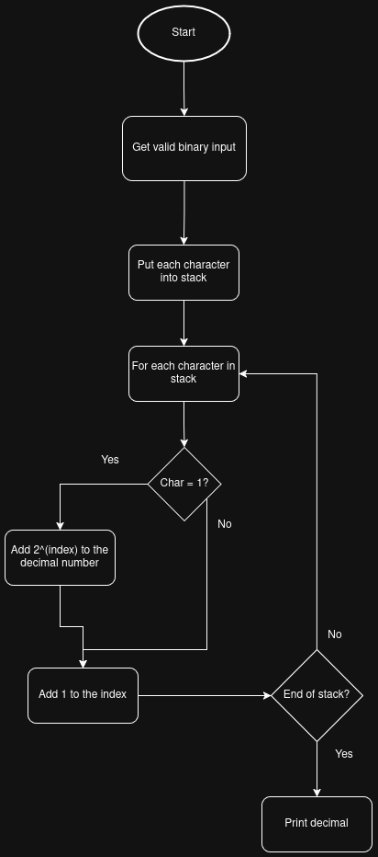
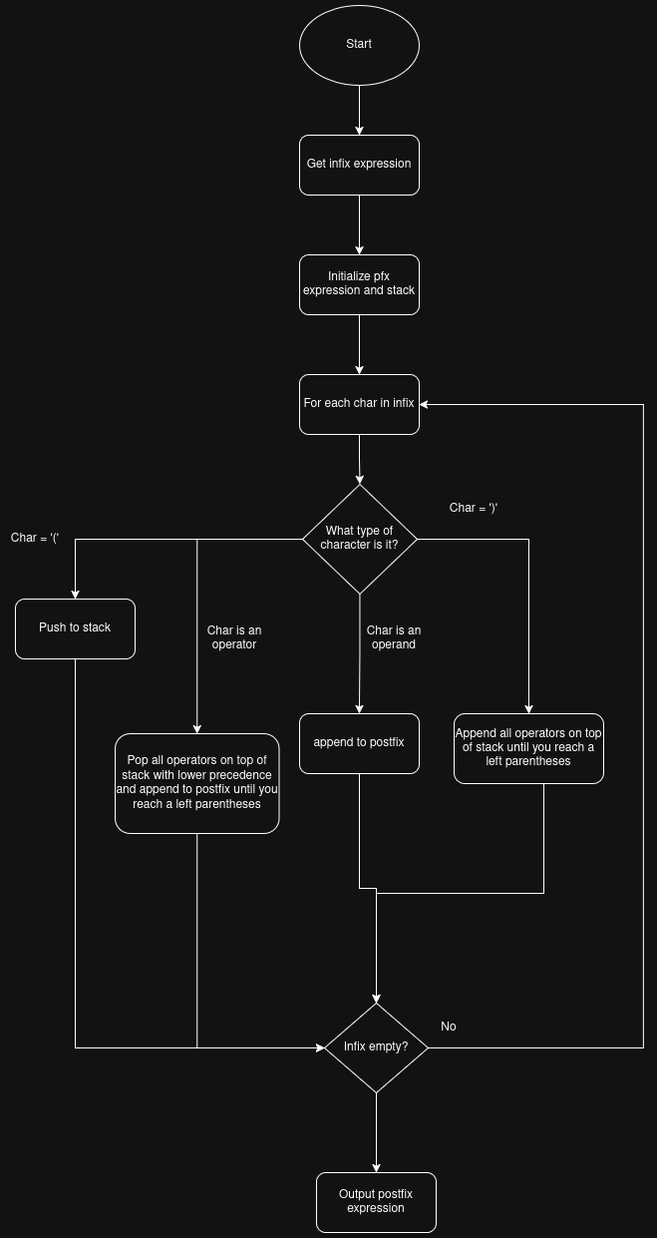

3 UML and Use Case Diagrams
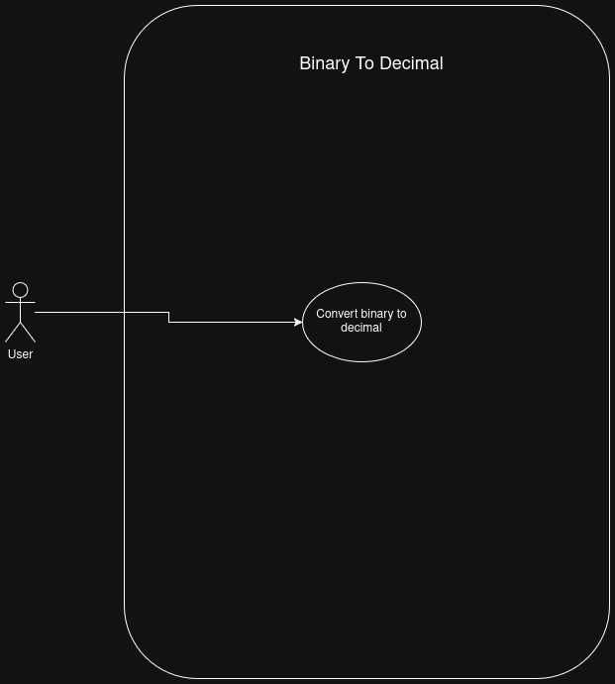
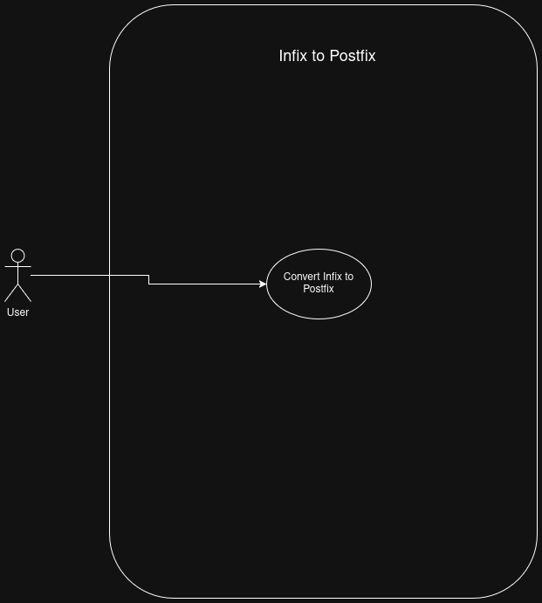

4 Source Code of All files (.h, .cpp)
Binary to Int:
#include <iostream>
#include <stack>
#include <string>
#include <math.h>

/*
Name: Convert Binary To Int
Author: Wesley Hixon
Date Last Updated: 11/11/2025
Purpose: Convert a binary number to integer using a stack
*/

int main(){
std::string binary;
std::stack<int> binaryStack;
int convertedInteger = 0;

std::cout << "Please enter a binary number: ";

bool valid = false;

// Validate the binary number
while(!valid){
std::cin >> binary;

valid = true;
for(char num : binary){
if(num != '1' && num != '0'){
std::cout << "Try again. Please enter a binary number:";
valid = false;
break;
}
}
}

// Push each digit to the stack
for(char num : binary){
int charToInt = num - '0';
binaryStack.push(charToInt);
}

int length = binaryStack.size();
int power = 0;

// Convert binary to decimal using powers of 2
while(power < length){
int digit = binaryStack.top();
if(digit == 1){
convertedInteger += pow(2, power);
}

binaryStack.pop();
power++;
}

std::cout << "This is your binary number in decimal: " << convertedInteger << std::endl;

return 0;
}

Infix to Postfix:
#include <iostream>
#include <string>
#include <stack>
#include <map>

/*
Name: Infix To Postfix
Author: Wesley Hixon
Date Last Updated: 11/11/2025
Purpose: Convert infix expressions to postfix expressions using a stack
*/

class expressionConvertor{
private:
std::string infix;
std::string postfix = "";
std::map<char, int> operatorPrecedence = {
{'*', 2},
{'/', 2},
{'+', 1},
{'-', 1}
};
public:
std::string showInfix() const {
return infix;
}
std::string showPostfix() const {
return postfix;
}
void storeInfix(std::string& inputInfix){
infix = inputInfix;
postfix = infixToPostfix(infix);
}

std::string infixToPostfix(std::string& inputInfix){
std::string outputPostfix;
std::stack<char> expStack;

for(char sym : inputInfix){
if(sym == '('){
expStack.push(sym);
}
else if(sym == ')'){

while(expStack.top() != '('){
outputPostfix += expStack.top();
outputPostfix += ' ';

expStack.pop();
}
// pop that last '('
expStack.pop();
}
else if(operatorPrecedence.find(sym) != operatorPrecedence.end()){

while(!expStack.empty() && expStack.top() != '(' && operatorPrecedence[expStack.top()] >= operatorPrecedence[sym]){
outputPostfix += expStack.top();
outputPostfix += ' ';

expStack.pop();
}

expStack.push(sym);
}

else if(sym == ' ') continue;
else{
outputPostfix += sym;
outputPostfix += ' ';
}
}

while(!expStack.empty()){
outputPostfix += expStack.top();
outputPostfix += ' ';

expStack.pop();
}

return outputPostfix;
}
};

int main(){
expressionConvertor obj;
std::string infx = "A + B - C";

obj.storeInfix(infx);
std::cout << "Infix: " << infx << std::endl;
std::cout << "Postfix: " << obj.showPostfix() << std::endl;

infx = "(A + B ) * C";
obj.storeInfix(infx);
std::cout << "Infix: " << infx << std::endl;
std::cout << "Postfix: " << obj.showPostfix() << std::endl;

infx = "(A + B) * (C - D)";
obj.storeInfix(infx);
std::cout << "Infix: " << infx << std::endl;
std::cout << "Postfix: " << obj.showPostfix() << std::endl;

infx = "A + ((B + C) * (E - F) - G) / (H - I)";
obj.storeInfix(infx);
std::cout << "Infix: " << infx << std::endl;
std::cout << "Postfix: " << obj.showPostfix() << std::endl;

infx = "A + B * (C + D) - E / F * G + H";
obj.storeInfix(infx);
std::cout << "Infix: " << infx << std::endl;
std::cout << "Postfix: " << obj.showPostfix() << std::endl;

return 0;
}

5 Three Use Case Screen Shots
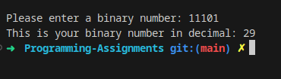
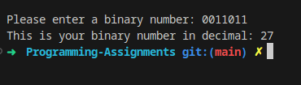
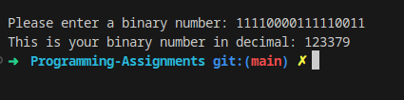
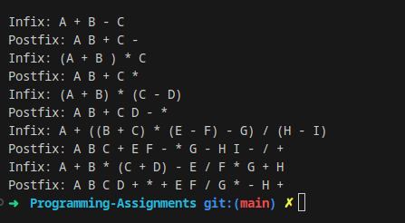

(Optional) GitHub URL

